CV Building
CV is short for Curriculum Vitae which is Latin. Translated to English, it means Course of Life.
So, a CV is an overview of someone’s life work. It is a summary of a person’s experience and interests.
The reason that it is useful for you to do one, is that when you start looking for a job, apprenticeship or other training, you can pass it on to an employer for them to see if you have the right skills and experience for a particular job or opportunity.
Do worry if you have not had much, or any work experience. An employer should not expect someone of your age to have done much work. First and foremost, they will want to know you about your skills and qualities.

When I ask employers what they are looking for from a young person, 9 out of 10 times the first thing they say is, Timekeeping. When you have an interview, you will likely to be asked about your strengths. It is always wise to mention your timekeeping and general reliability.

When writing your CV, remember it is formal writing and it is important to take time to ensure you have checked for; spelling, grammar, punctuation, sentence structure and the general layout. Common mistakes that people make are:

- Not using Capital Letters for Proper Nouns such as; Bristol, Blaise High School
- Writing i instead of I when mentioning about yourself
- Getting the spacing and punctuation right on a Postcode – should all be capital letters with a space between the two parts eg; BS10 7ZZ
- Using apostrophes instead of the full word

It sounds harsh but it is common for employers not to shortlist candidates for spelling mistakes or any of the above reasons.
Also, please note that a CV should only be one or two pages long. Employers often get many CVs, so they want to be grabbed by the information which needs to be relevant to the job. Many will end up in the bin (or recycled) if it is lengthy, no matter how brilliant the candidate may be.

Below are the different steps to take in building your CV, from start to finish:

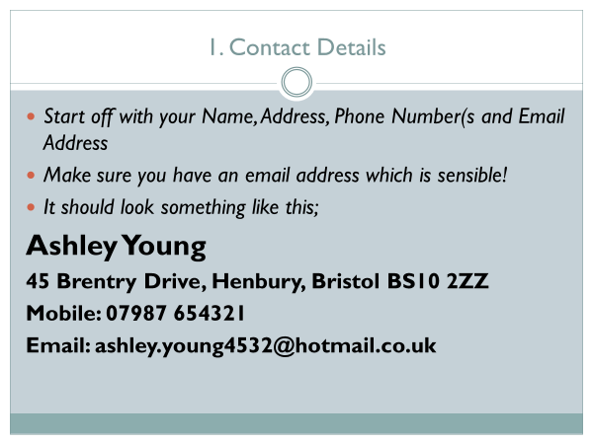

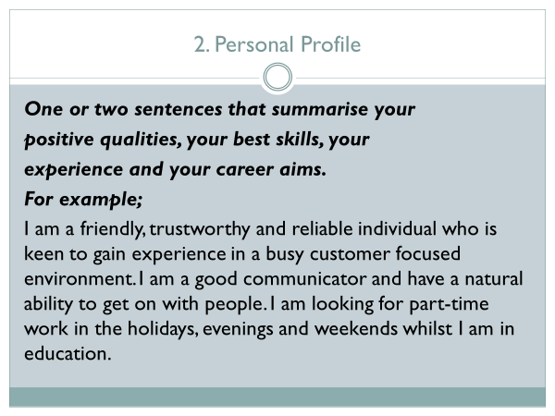

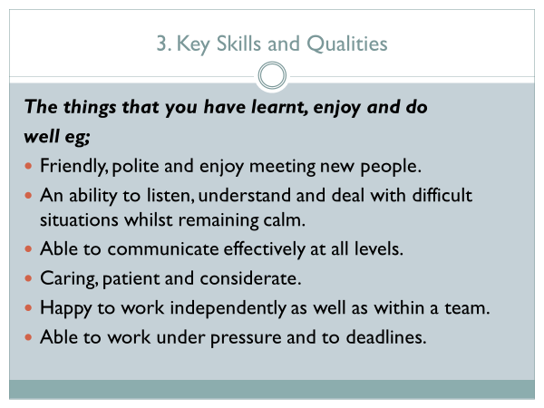
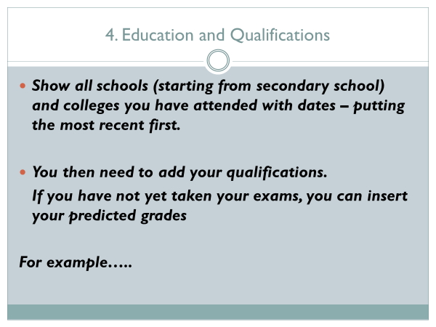

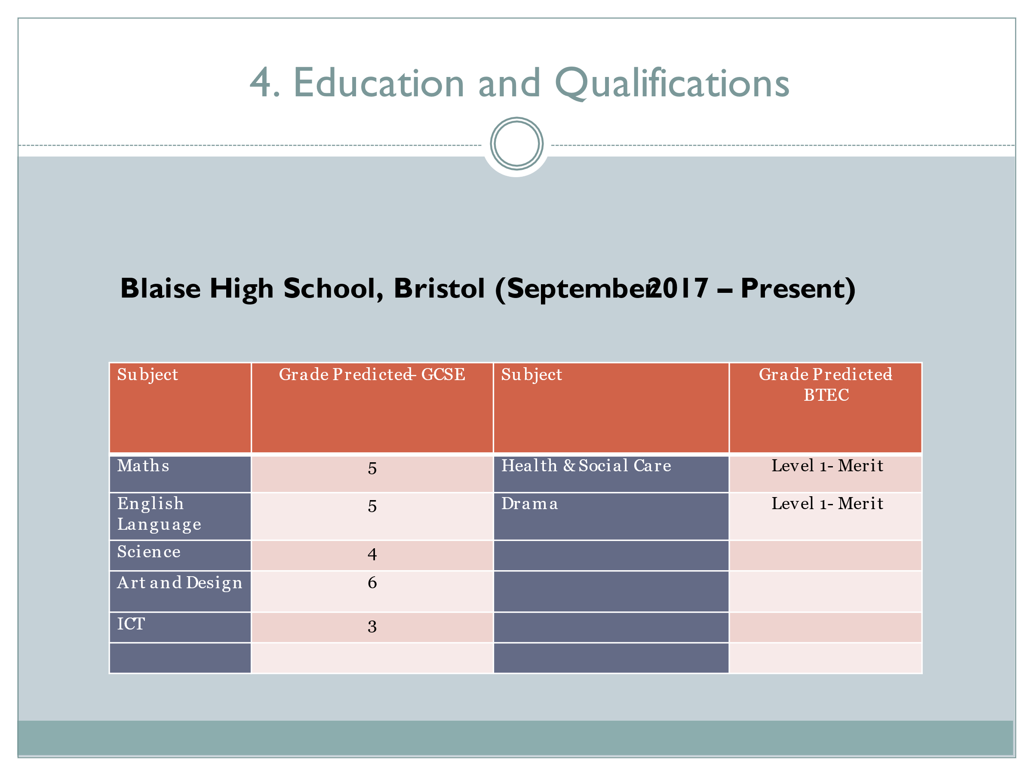

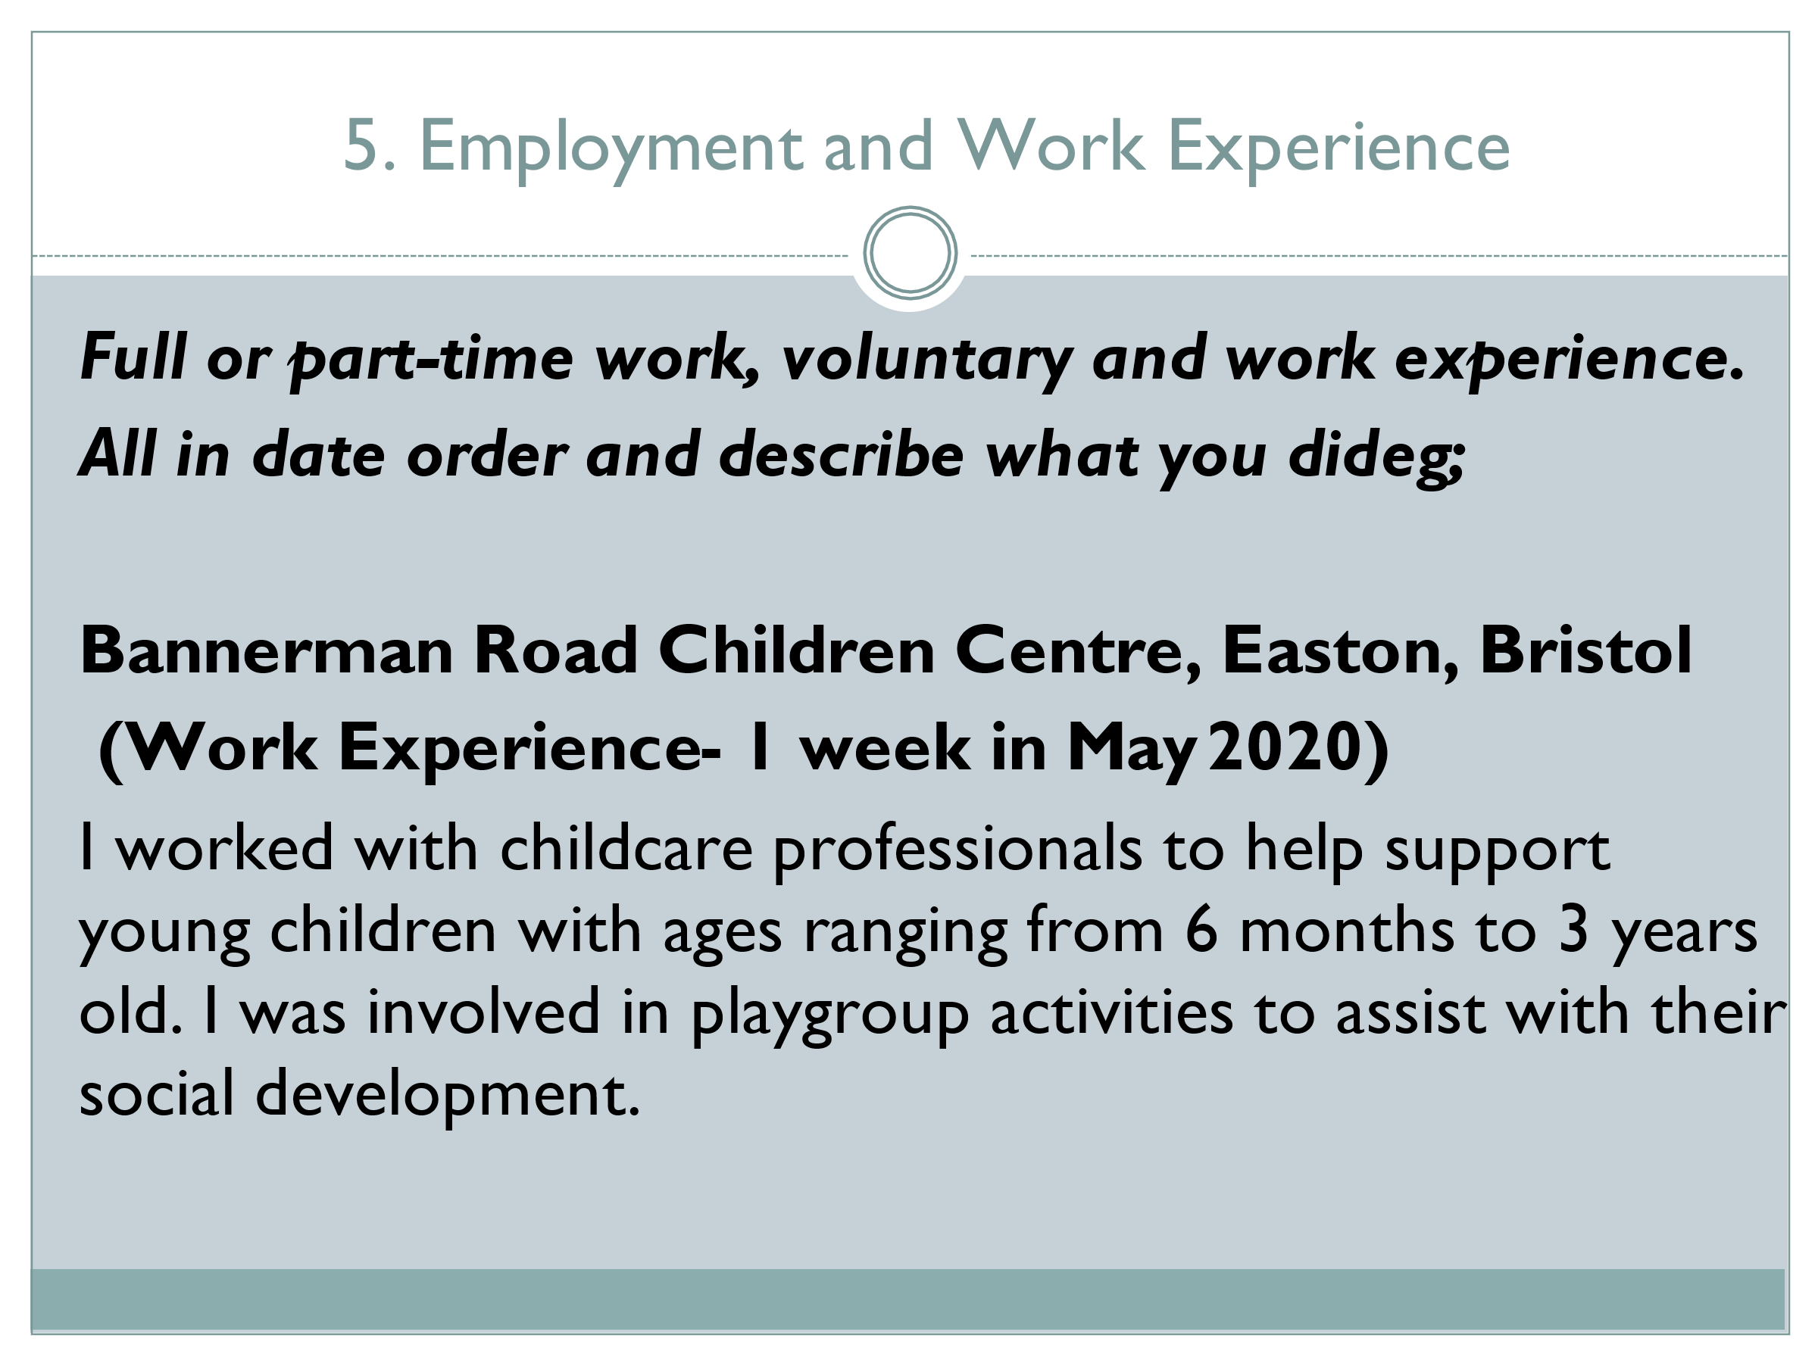

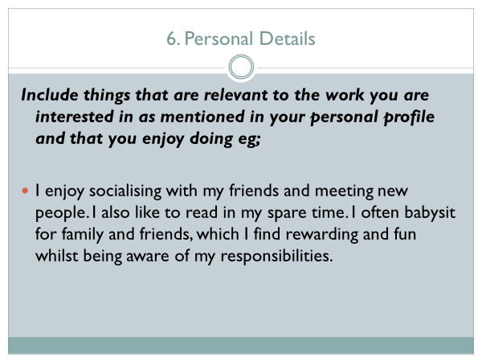
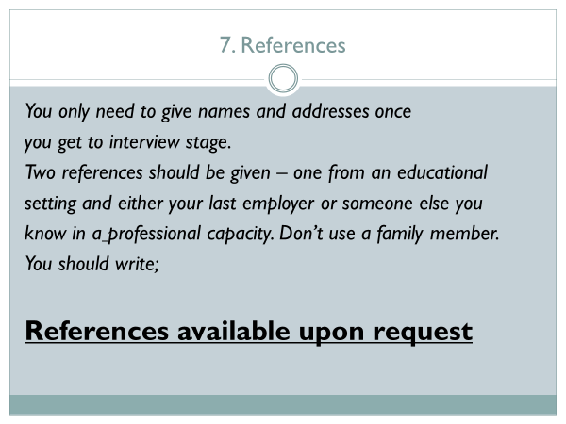

That’s your CV completed – now a bit of advice:
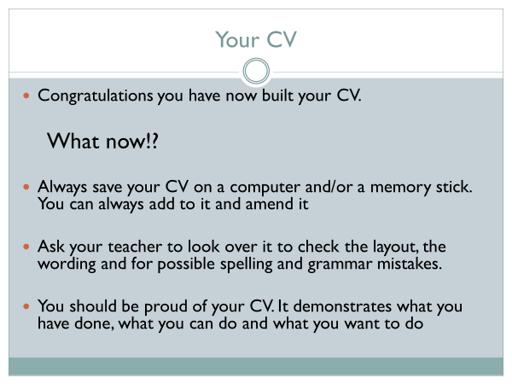
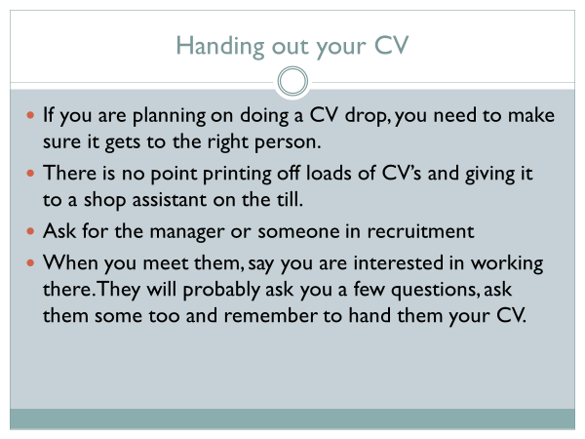
There are many CV Builders and templates available online. Here is a link to some and other related information:
https://www.careerpilot.org.uk/information/a-job-or-career/cv-builder

