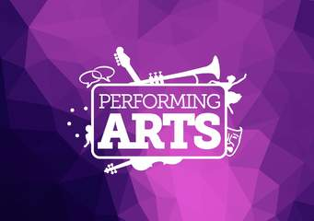
Year 11 transition BTEC Level 3 National Extended Diploma in Performing Arts

Complete all activities.

Activity 1 – Subject Knowledge Audit
Create a Biography of your experience and knowledge of both drama and theatre under the following headings:
Plays I have read:
Performances I have seen:
Performances I have been in:
Practitioners/Playwrights I Know:
Specific Skills/Techniques I have:
Activity 2 – Short Essay – 500 words (include 2 quotes)
‘What is the difference between Drama and Theatre?’

Activity 3 – Performance Review Essay – 500 words
With reference to one live performance experience, explain why the performance was effective for you us as a member of the audience. You may want to comment on one/some of the following:
- A particular actor and their use of performance skills
- Use of staging and Performance Space
- Use of technical design elements (set/lights/sound/costume)
*Ensure you state the title of the production.

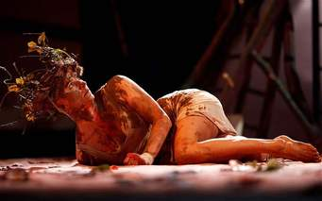
Activity 4 - As part of the course you will be looking at practitioners and theatre companies. Research the theatre company “Kneehigh”.
Independent Learning Task(s) to Complete:
1. Join the Kneehigh Cookbook website to access resources and learn about the company. https://kneehighcookbook.co.uk/
2. Watch all of the Kneehigh YouTube clips below and make notes on all production / storytelling elements used. How many techniques can you spot? Make notes on your first impressions of Kneehigh's style.

Youtube links for Kneehigh’s style:
https://www.youtube.com/watch?v=Tlebr9TZG98 - FUP, a modern fable
https://www.youtube.com/watch?v=OiM3whG9Oxs – Rebecca trailer
https://www.youtube.com/watch?v=D1KXcmFrJW4 – Tin Drum trailer
https://www.youtube.com/watch?v=8pnl_7WIFtg – Brief Encounter trailer
https://www.youtube.com/watch?v=5nFpFdCFbFo – Adolphus Tips trailer
https://www.youtube.com/watch?v=TyHKir0CfeE – Hansel and Gretel trailer
https://www.youtube.com/watch?v=KT_dlFtMiKs – The Wild Bride trailer

Activity 5: Research the 5 key areas of vocal technique below. Write a report or presentation based on each element within the 5 key areas, describing each point and stating the importance of each element and how it impacts on the voice within Musical Theatre.
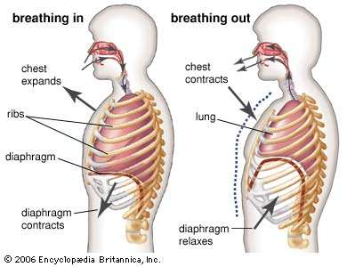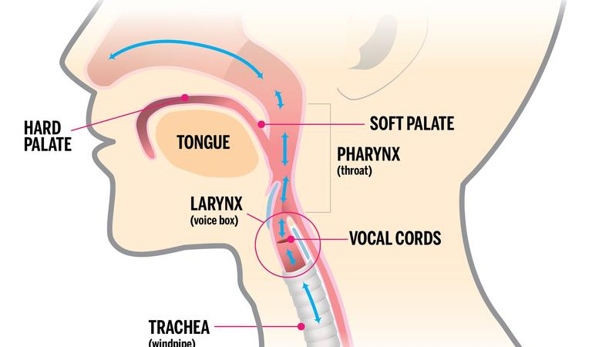
Area 1 - The role of the body:
- Spine; head; neck; shoulders; arms; sternum; ribcage; abdominal muscles; pelvic area; knees; ankles; facial muscles; cheeks; forehead; jaw.
- Centring
- Weight placement
- Posture:
- Alignment of head, neck, spine and pelvic area. Position of arms, legs and stance when standing or sitting when singing.
- tension: knees, back, shoulders, face muscles, jaw, arms.
Area 2 – Breath:
- respiration process
- diaphragm and the role of the abdominal support muscles to develop breath
- Lungs
- Ribcage
- Breath placement
- Breath capacity
- Effect on tension on breath capacity.
Area 3 – Sound:
- Larynx
- Vocal folds
- Main areas of support for vocal resonance: head, nose, face/mouth, throat/pharynx, chest
- Effect on placing the sound: back of mouth, soft palate, hard palate, as far forward in the mouth as possible.
Area 4 – Articulation:
- jaw
- lips
- mouth
- soft palate
- hard palate
- tongue
- pharynx/throat

Activity 7: Review and evaluate your performance from task 2. You should discuss the following points in your written evaluation:
- Technical skills you have used
- Technical skills you could include in order to improve next time
- Developmental skills that you have used
- Developmental skills that you could include in order to improve next time.
- Strengths
- Feedback/weaknesses/areas for improvement
- Target setting for the future
Activity 6: Choose one song from a larger musical theatre performance. Perform at least 1 minute 30 seconds of the song, video recording your performance for submission. After the performance, explain how you used your body, centring, weight placement, posture and tension during your performance (using the points from Task 1 for reference.)
