Year 11 Geographers - Get ready for A Level
Complete 3 of the following 6 projects, the choice is yours. When complete submit them, either through google classrooms or to sixthform@hphigh.co.uk
Project 1 Water
Open Learn Course Global water resources
Task Complete this free on-line course from the Open University. We study water security at A level – this is a perfect introduction. By completing this course you will understand the future of global water resources, including problems of water scarcity and water security nationally and internationally
Resource https://www.open.edu/openlearn/science-maths-technology/science/environmental-science/global-water-resources/content-section-4#

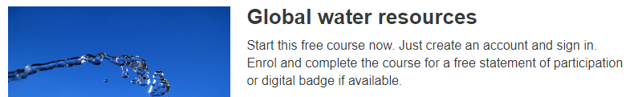
Submit - When you have finished the course you will receive a ‘statement of participation’, submit a copy.

Project 2 Coasts
Open Learn Course Managing coastal environments
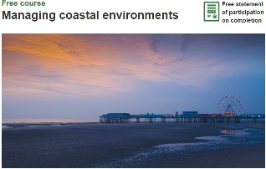
Task This free on-line course is looking at managing coastal environments. This builds upon what you have done at GCSE ready for the coastal topic at A level. This course will guide you through the challenges of managing a coast that is constantly changing, leaving some winners but also some losers.
Resource https://www.open.edu/openlearn/nature-environment/the-environment/environmental-science/managing-coastal-environments/content-section-0

Submit When you have finished the course you will receive a ‘statement of participation’, submit a copy.

Project 3 Local Fieldwork – Place identity
Objective Research on the ‘Place identity’ of Gloucester (or another town of your choice). This allows you to undertake independent fieldwork and understand the many of the aspects of place identity of Gloucester

Follow the instructions below (read the safety instructions at the bottom prior to starting this project):
1. Print out a copy of the clone town survey found at https://www.rgs.org/CMSPages/GetFile.aspx?nodeguid=eb692e7d-9d99-415f-a5ee92c13a4962d7&lang=en-GB
2. Visit Gloucester (or chosen town) and complete the survey to see to what extent it is a clone town
3. Download “Skitch” to your phone, and use it to take the photos listed below and label them
A photograph to show:
- Urban decline
- Urban regeneration
- An historical aspect of the town
- A modern aspect of the town
- An environmental problem
- An area of the town that could be described as ‘successful’
- An area of the town that could be described as ‘unsuccessful’
- What Gloucester represents to you
- What Gloucester represents to an older member of your family
4 Using the clone town survey and your photos, create a document that answers 2 key questions:
a Is Gloucester (your chosen town) a clone town? - to include:
- What evidence do you have
- What are the advantages ?
- What are the disadvantages?
b What is the Place identity of Gloucester? – to include
- Your annotated photos
- An explanation of how Gloucester (your chosen town) could be described as successful but also as unsuccessful
Submit Your document.

You must undertake this safely by:
- Going with at least one other person
- Ensuring that your parents / carer are aware of when / where you are going
- Undertaking the fieldwork in the daytime
- The current lockdown rules have been lifted.
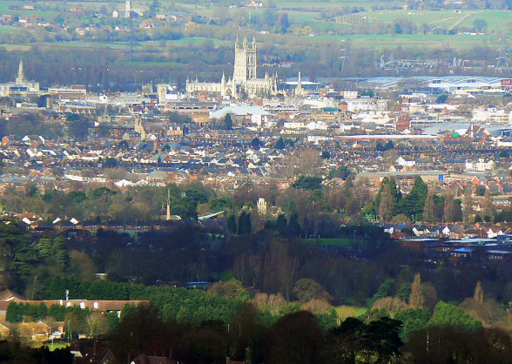

Project 4 Tectonics
Objective – To complete an overview of the cause, effect and management of the tectonic hazards of volcanoes, earthquakes and tsunamis, including a case study of each.
1 Causes of tectonic hazards. There are 3 main types of plate boundaries, convergent, divergent and transform. For each one:
- Draw a quick diagram
- label it
- Explain how the boundary results in a tectonic hazard (earthquake, volcano or tsunami)
2 Research into the key hazardous events of:
Volcano – Icelandic 2010 (Eyjafjallajökull) Earthquake – Haiti 2010 Tsunami – Japan 2011
For each one can do a brief fact file of :
- Cause
- Short term effects (What happened in the days/weeks months following?)
- Long term effects (What is the situation now? Are they still suffering from the event?)
- Management (How did people try to reduce the effects?)
Resources
Volcano – Icelandic 2010 (key here is the economic impact – why did it cost so much?)
http://www.coolgeography.co.uk/A-level/AQA/Year%2013/Plate%20Tectonics/Volcanoes/MEDC%20case%20study.htm
Earthquake – Haiti 2010 (this is a desperate situation, ensure you have details about how the event is still effecting people now)
http://www.coolgeography.co.uk/A-level/AQA/Year%2013/Plate%20Tectonics/Earthquakes/LEDC%20Case%20study.htm
https://handygeography.wordpress.com/gcse/the-restless-earth-revision-materials/earthquake-case-study-haiti-poor/
Tsunami – Japan 2011 (include information about the nuclear power station)
https://www.livescience.com/39110-japan-2011-earthquake-tsunami-facts.html

Submit Your document.

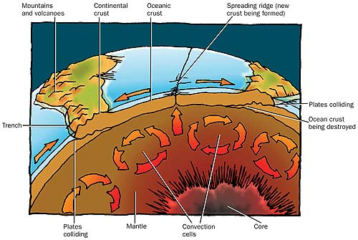

Project 5 Water cycle and insecurity
Objective – To complete an overview of the water cycle and water insecurity by answering these questions.
Independent Research
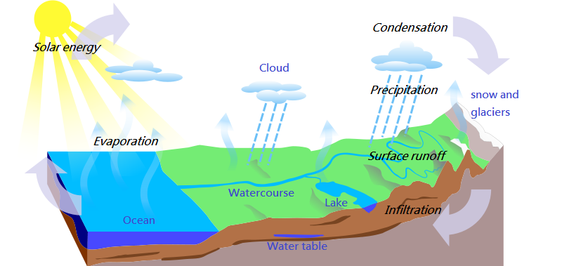
- What affect can humans have on the hydrological cycle?
- What is a storm hydrograph and what factors can impact it? (Physical and human)
- How have humans contributed to drought in Australia?
- How might climate change impact the hydrological cycle?
- What are the human and physical causes of water insecurity?
- Draw the hydrological cycle and label its inputs, outputs, stores and flows
- Describe the patterns of water scarcity shown on the map below.
- Using the following website, which areas of the UK are most at risk of flooding?
http://watermaps.environment-agency.gov.uk/wiyby/wiyby.aspx?topic=floodmap#x=357683&y=355134&scale=2
- What issues may be present when a river flows through more than one country?
- Why are treaties like ‘The Helsinki Rules on the Use of Water’ important in managing water supply?

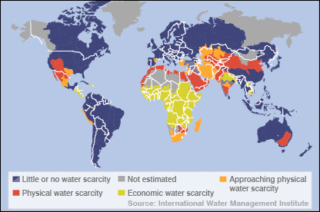

Submit – Your document

Project 6 Globalisation
Objective – To complete an overview of the issues surrounding globalisation by following the instructions:
- Define ‘Globalisation’
- Read the information on the next page. Highlight one key word from each box.
- How globalised are you? Take a photo of yourself / a room in your house with some of your possessions. Annotate all the countries that 'you are wearing / have'.
- Use https://www.bbc.co.uk/bitesize/guides/zxpn2p3/revision/4, to identify the positives of globalisation
- Usehttps://www.bbc.co.uk/bitesize/guides/zxpn2p3/revision/5, to identify the negatives.
- Study the diagram and the map below. It shows where the parts from a plane comes from and operations of Airbus around the world. Watch https://www.youtube.com/watch?time_continue=16&v=5wqrrgiw37o&feature=emb_logo
And answer :
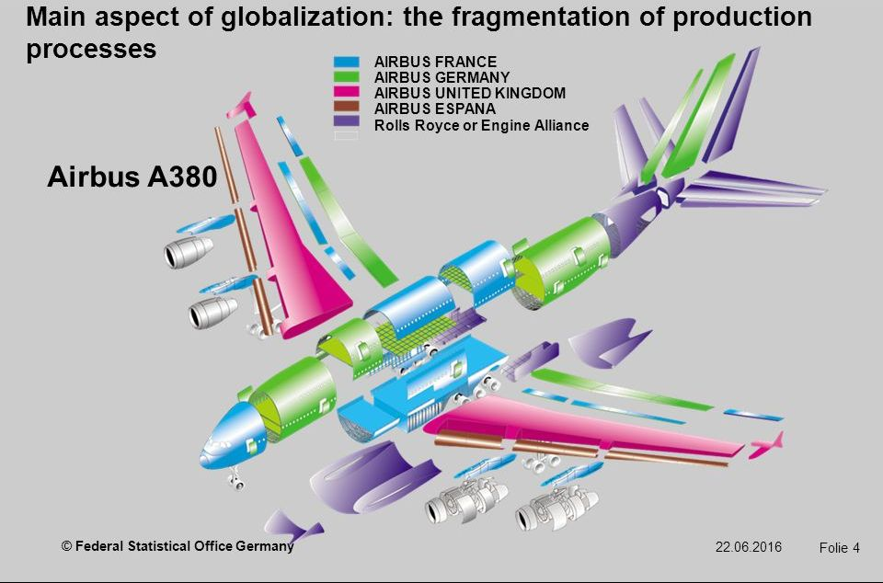
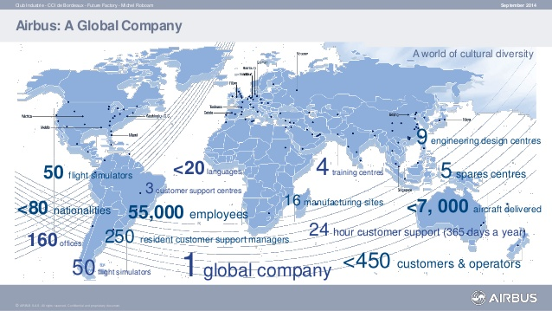
a What has been the role of technology in enabling Airbus to operate across the world?
b What economic factors have contributed to their growth and spread?
c What have the impacts at a local, national and global scale been?

Submit –Your document

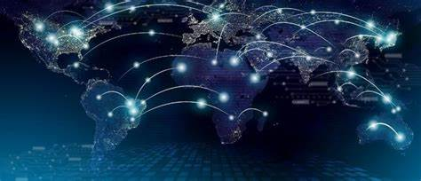
What causes Globalisation to happen?
Better technology connecting more people
What makes the rest of this list possible is the ever-increasing capacity for and efficiency of how people and things move and communicate. In years past, people across the globe did not have the ability to communicate and could not interact without difficulty.
Nowadays, a phone, instant message, Skype, FaceTime or video conference call can easily be used to connect people.
Mobile phone technology has allowed this to happen to a large extent as most people around the world now have access to a mobile. (currently 85% of people in Africa have a mobile!)

People moving between places (migration)
A general increase in awareness, opportunity and transportation technology has allowed for people to move about the world in search of a new home, a new job, or to flee a place of danger (Syria – Sweden).
Most migration takes place within or between developing countries, possibly because of lower standards of living and lower wages push individuals to places with a greater chance for economic success.
Money moving between places
Capital (money) is being moved globally with the ease of electronic transference and a rise in perceived investment opportunities. Developing countries are a popular place for investors to place their capital because of the enormous room for growth.
Transfers on Amazon, PayPal, eBay etc can all be done with a click of a button.

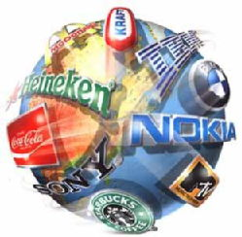
Better transportation making it easier to get to places
Anyone with the funds and relevant passport & visa can book a plane flight and show up half way across the world in a matter of hours.
In short, the "friction of distance" is lessened, and the world begins to metaphorically shrink.
Airbus A380 contributes towards this too. More people, further distances and for cheaper than ever before!
More and more transnational companies (TNC).
As countries are connected to the rest of the world (through increased communication and transportation) they immediately form what a business would call a market. What this means is that a particular population represents more people to buy a particular product or service. As more and more markets are opening up, business people from around the globe are coming together to form multinational corporations in order to access these new markets. Another reason that businesses are going global is that some jobs can be done by foreign workers for a much cheaper cost than domestic workers; this is called outsourcing.
People sharing knowledge
The word 'diffusion' simply means to spread out, and that is exactly what any newfound knowledge does. When a new invention or way of doing something pops up, it does not stay secret for long. A good example of this is the appearance of a new cheat for a game / instructional video on YouTube of how to repair an iPhone screen yourself etc

