Unit 1: AC4.1-5.
Food Safety
LO4: Know how food can cause ill health.
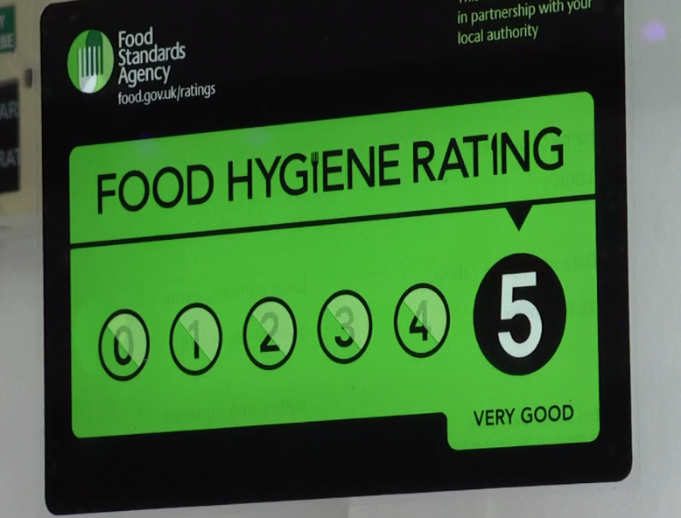

My Food Safety Documentation
Part 3

Name___________________________________________________
Form_______________________ Target Grade: _________________

AC4.2: Describe the role and responsibilities of the Environmental Health Officer (EHO)

You must know:
Role
- Enforcing environmental health laws
Responsibilities
- Inspecting business for food safety standards
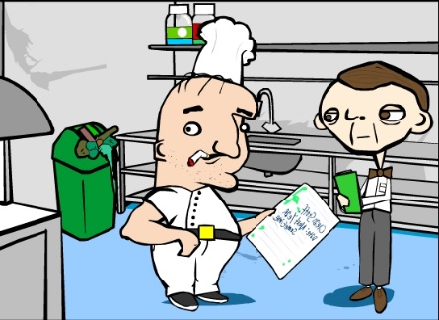
- Follow up complaints
- Follow up outbreaks of food poisoning
- Collecting samples for testing
- Giving evidence in prosecutions
- Maintaining evidence
- Submitting reports

It is also the role of the EHO to give a food premises it’s hygiene rating. This is made public so is very important to a food business.
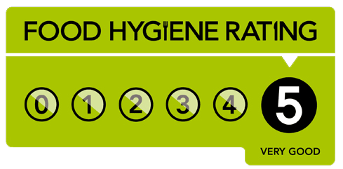

What must you register with before you start to serve food in your hotel?
……………………………………………………………………………………………………………………………………………………………………………………………………………………………………………………

What are will you expect the EHO to do when he/she inspects your premises?
……………………………………………………………………………………………………………………………………………………………………………………………………………………………………………………………………………………………………………………………………………………………………………………………………………………………………………………………………………………………………………………………………………………………………………………………………………………………………………………………………………………………………………………………………………………………………………………………………………………………………………………………………………………………………………………………………………………………………………………………………………………………………………………………………………………………………………………………………………………………………………………………………………………………………………………………………………………………………………………………………………………………………………………………………………………………………………………………………………………………………………………………………………………………………………………………………………………………………………………………………………………………………………………………………………………………………………………………………………………………………………………………………………………………………………...

What do you think you will have to show the EHO?
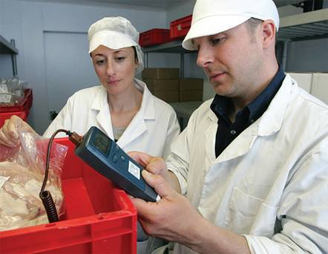
…………………………………………………………………………………………………………………………………………………………………………………………………………………………………………………………………………………………………………………………………………………………………………………………………………………………………………………………………………………………………………………………………………………………………………………………………………………………………………………………………………………………………………………………………………………………………………………………………………………………………………………………………………………………………………………………………………………………………………………………………………………………………………………………………………………………………………………………………………………………………………………………………………………………………………………………………………………………………………………………………………………………………………………………………………………………………………………………………………………………………………………………………………………………………………………………………………………………………………………………………………………………………………………………………………………………………………………………………………………………………………………………………………………………………………….................................................................................................................................................................................................................................................................................................................................................................................................
What will happen if the EHO finds something wrong when inspecting your hotel?
…………………………………………………………………………………………………………………………………………………………………………………………………………………………………………………………………………………………………………………………………………………………………………………………………………………………………………………………………………………………………………………………………………………………………………………………………………………………………………………………………………………………………………………………………………………………………………………………………………………………………………………………………………………………………………………………………………………………………………………………………………………………………………………………………………………………………………………………………………………………………………………………………………………………………………………………………………………………………………………………………………………………………………………………………………………………………………………………………………………………………………………………………………………………………………………………………………………………………………………………………………………………………………………………………………………………………………………………………………………………………………………………………………………………………………………………………………………………………………………………………………………………………………………………………………………………………………………………………………………………………………………………………………………………………………………………………………………………………………………………………………………………………………………………………………………………

Food Safety Act 1995:
- Keep yourself clean.
- Keep the workplace clean.
- Wear suitable clothing.
- Protect food from contamination.
- Store, prepare & serve food at the correct temperature.
- Inform a manager if you are ill.
- Do not work with food if you have symptoms of food poisoning.

AC4.3: Job Roles: Qualifications: EHO

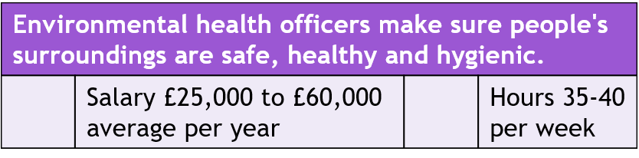




What qualifications will you need if you want to become an environmental health officer?
…………………………………………………………………………………………………………………………………………………………………………………………………………………………………………………………………………………………………………………………………………………………………………………………………………………………………………………………………………………………………………

What skills does an Environmental Health Officer need to have?
………………………………………………………………………………………………………………………………………………………………………………………………………………………………………………………………………………………………………………………………………………………………………………………………………………………………………………………………………………………………………………………………………………………………………………………………………………………………………………………………………………………………………………………………………………………………………………………………………………………………………………………………………………………………………………………………………………………………………………………………………………………………………………………………………………………………………………………………………………………………………………………………………………………………………………………………………..

What would you expect to have to do as an EHO?
……………………………………………………………………………………………………………………………………………………………………………………………………………………………………………………………………………………………………………………………………………………………………………………………………………………………………………………………………………………………………………………………………………………………………………………………………………………………………………………………………………………………………………………………………………………………………………………………………………………………………………………………………………………………………………………………………………………………………………………………………………………………………………………………………………………………………………………………………………………………………………………………………………………………………………………………………………………………………………………………………………………………………………………………………………………………………………………………………………………………………………………………………………………………………………………………………………………………………………………………………………………………………………………………………………………………………………………………………………………………………………………………………………………………………………..

Search the internet for additional information about food inspections and the role of the EHO so you know fully what to expect. Attach or record additional information in the space below.

