Transition Pack
A-Level Chemistry

Research Task
2020
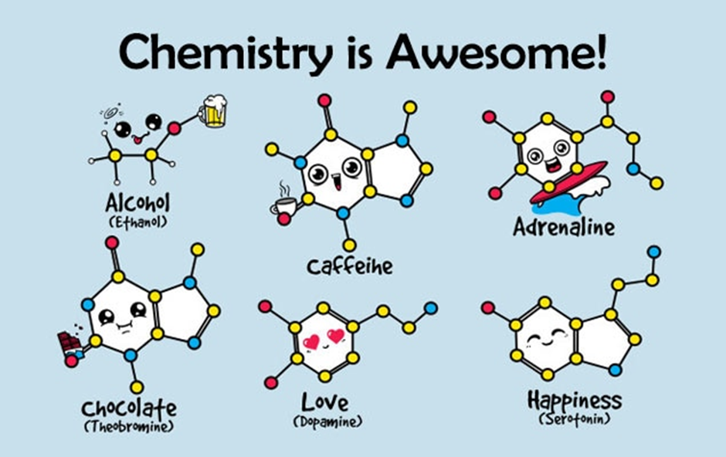
http://selkiegrey4.blogspot.com/2019/12/chemistry-on-my-mind.html

Chemistry Research Activity
To prepare you for A-level Chemistry there are six topics that we would like you to research, two of which you research to a greater depth.

Task 1: Make a single page of Cornell notes addressing each topic.
Click this link for an explanation of this note style and see the next page. Feel free to include diagrams where appropriate.

The six topics with some hints are:
- Women in Chemistry.
The contribution of women to Chemistry is often overlooked. Women were not supposed to work once they were married and sometimes the woman could only publish under her husband’s name! Select five women from the list and explain in detail what their contribution was.

- Why is copper sulphate blue?
Copper compounds like many of the transition metal compounds have got vivid and distinctive colours – why?

- More energy.
Our need for fast reliable and sustainable energy sources has never been greater. Research how scientists are developing new ways to solve this problem.

- The development of the model of the atom.
What is the current model of the atom? Why do we use this one? Research all the scientists that contributed to the current model including any experiments they did.

- The chemistry of fireworks.
What are the component parts of fireworks? What chemical compounds cause fireworks to explode? What chemicals are responsible for the colour of fireworks?

- The discovery and chemistry of Aspirin.
What was the history of the discovery of aspirin, how do we manufacture aspirin in a modern chemical process?

-------------------------------------------------------------

Task 2: Research two of the topics to greater detail.
Choose two of the topics above, we suggest the ones you find most interesting, and research them to greater depth. Find out as much as you can about each topic.
Impress us with your knowledge!
As a guide, we suggest you at least answer the following questions through your research:
- How did this affect science going forward?
- Who was involved in this and/or built upon this?
- When and where was this discovered?
- Why do you believe this is important?

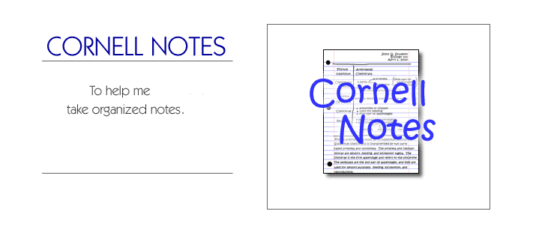
How to make Cornell Notes.

Step 1: Step 2:
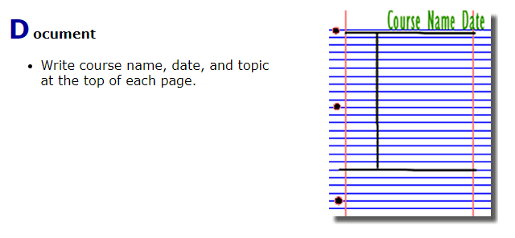
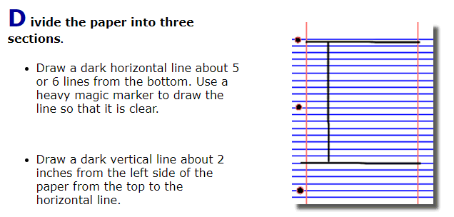

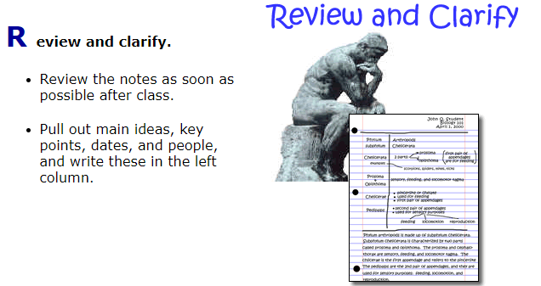
Step 3: Step 4:
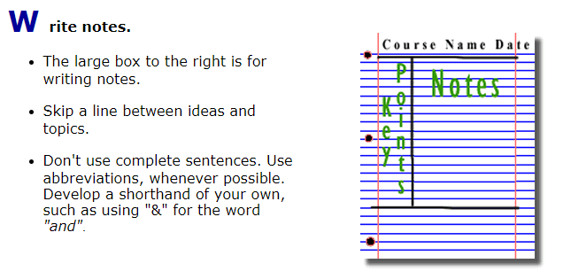
Step 5: Step 6:
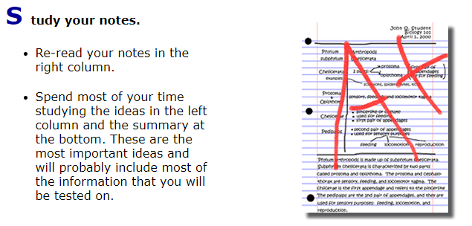
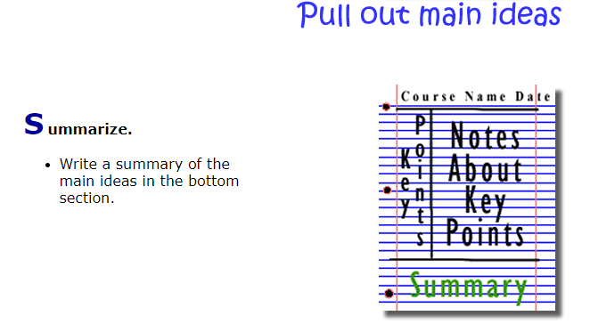

Figure 2: http://coe.jmu.edu/learningtoolbox/images/noteb4.gif

