YEAR 12 FURTHER MATHS INDUCTION BOOKLET

Thank you for choosing to study Further Maths in the sixth form
Over the course, you will study topics in Core Pure Maths, Further Mechanics and Decision maths.
For you to make the best possible start, we have prepared this booklet. It is vital that you spend time working through this booklet over the next few months as you need to have good knowledge of these topics before you start the course. You will have covered most of the topics already at GCSE.

1. Completing the Square

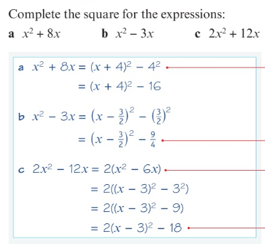
Examples

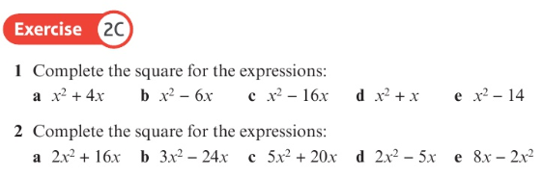
Deliberate Practice

Examples
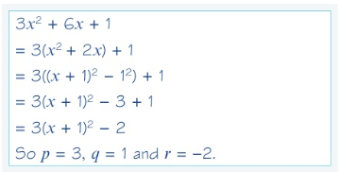

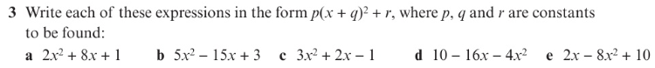
Deliberate Practice
Challenge
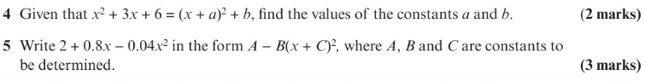
2. Solving Quadratics by completing the square
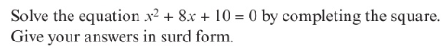
Example

$${\left(x+4\right)}^{2} -4^{2}+10=0$$
$${\left(x+4\right)}^{2}-16+10=0$$
$${\left(x+4\right)}^{2}-6=0$$
$${\left(x+4\right)}^{2}=6$$
$$x+4= ±\sqrt{6}$$
$$x= -4 ±\sqrt{6}$$
Deliberate Practice
Example

$$2\left(x^{2}-4x\right)+7=0$$
$$2 \left({\left(x-2\right)}^{2}-2^{2}\right)+7=0$$
$$2\left({\left(x-2\right)}^{2}-4\right)+7=0$$
$$2{\left(x-2\right)}^{2}-8+7=0$$
$$2{\left(x-2\right)}^{2}-1=0$$
$$2{\left(x-2\right)}^{2}=1$$
$${\left(x-2\right)}^{2}=\frac{1}{2}$$
$$x-2= ±\frac{1}{\sqrt{2}}$$
$$x=2 ±\frac{1}{\sqrt{2}}$$

Deliberate Practice
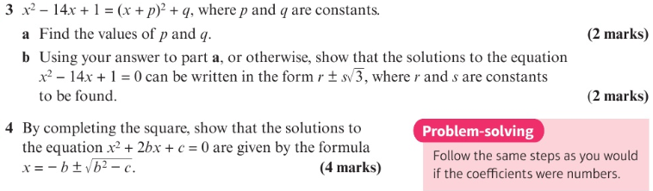
Challenge

3. The Discriminant
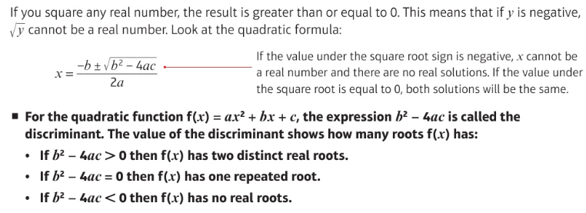

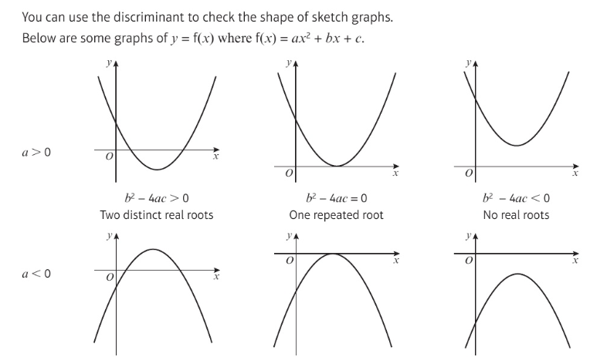

Example
Calculate the value of the discriminant of $f\left(x\right)=x^{2}+4x-5$and state how many roots it has.
$$Discriminant=b^{2}-4ac$$
$${\left(4\right)}^{2}-4\left(1\right)\left(5\right)=16-20= -4<0 so no real roots$$

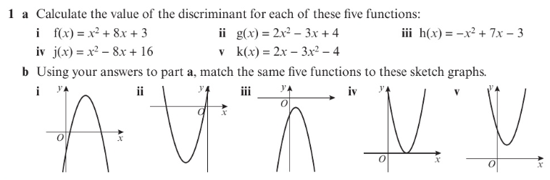
Deliberate Practice

4. Equation of a circle
For this section you will need to complete the following tasks on Hegarty maths before attempting the questions:
- 778 – Equation of a circle – centre origin (1)
- 779 – Equation of a circle – centre origin (2)
- 314 – Equation of a circle 1
- 315 – Equation of a circle 2
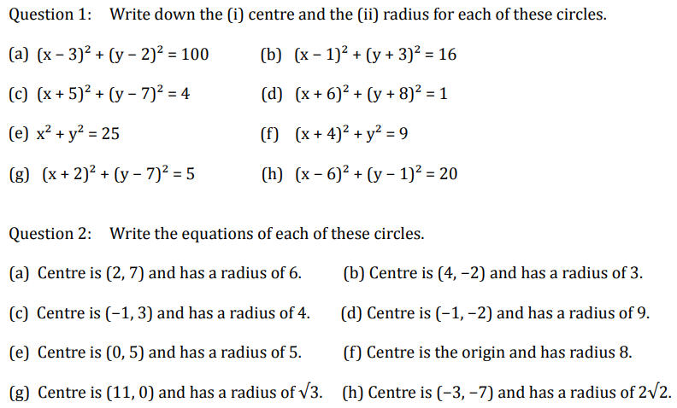
Deliberate Practice

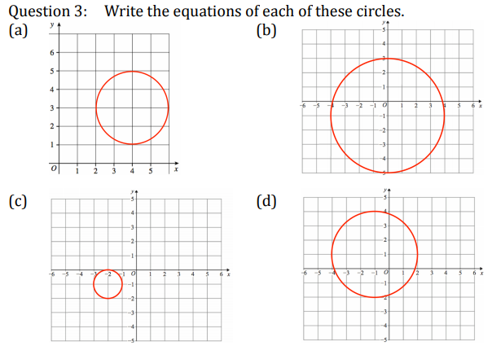

5. Column Vectors
For this section you will need to complete the following tasks on Hegarty maths before attempting the questions:
- 623 Vectors (2) – Column vectors
- 626 Vectors (5) – Multiplying by scalars
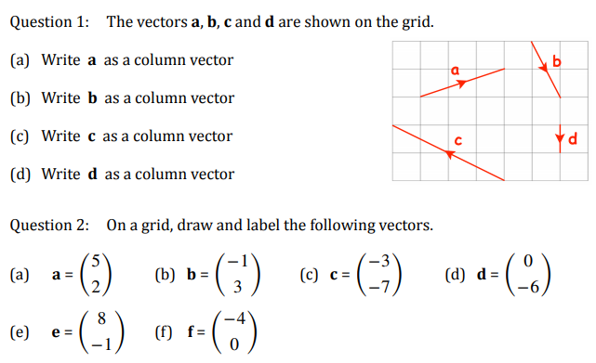
Deliberate Practice

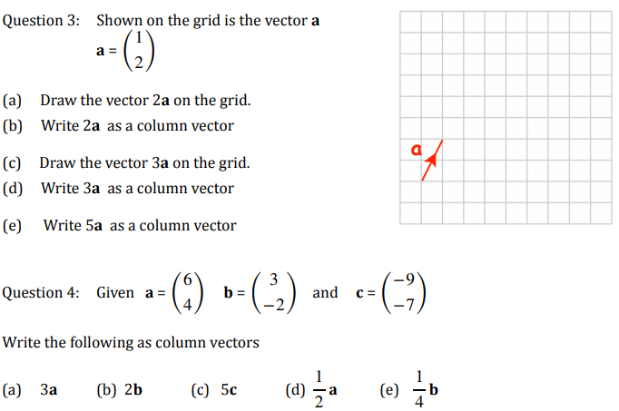

Question 5
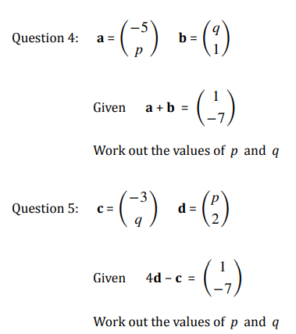
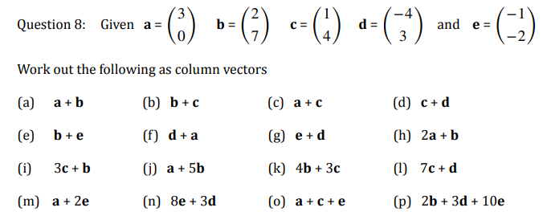
Question 7
Question 6

6. Vectors – geometric problems
For this section you will need to complete the following tasks on Hegarty maths before attempting the questions:
- 628 Vectors – geometry problems (1)
- 629 Vectors – geometry problems (2)
- 630 Vectors – geometry problems (3)
- 631 Vectors – geometry problems (4)
Deliberate Practice

Question 1
OPT is a triangle.
M is the midpoint of OP. $\overset{→}{OT}=a$ $\overset{→}{ TP}=b$
Express $\overset{→}{OM}$in terms of $a$and $b$.

$\overset{→}{OM}=$ .......................... (2 marks)

Question 2
In triangle $OPQ$, $\overset{→}{OP}$= 6a and $\overset{→}{OQ}$= 6b
$X$ is the midpoint of $PQ$. We can deduce that $\overset{→}{OX}=$3a + 3b
$Y$is the point on $OX$ such that $OY:YX=2:1$
Find, in terms of a and b, the vector $\overset{→}{QY}$Give your answer in its simplest form.

$\overset{→}{QY}=$ .......................... (2 marks)

