Transition Pack
A-Level Biology

Research Task
2020

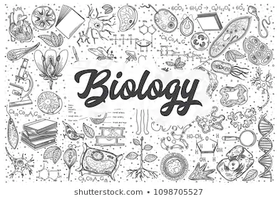
This pack is part of the programme of activities and resources to prepare you to start A-level Biology in September.
For any queries contact:

Biology Research Activity
To get ready for A-level Biology, there are six questions that we would like you to research, two of which you research to a greater depth.

Task 1: Make a single page of Cornell notes answering each question.
Click this link for an explanation of this note style and see the next page. Feel free to include diagrams where appropriate.
The six questions are:
- How does our immune system try to deal with COVID-19?
- Why are bees disappearing and should we worry?
- What are the implications of climate change for health?
- What is the importance of proteins in life processes?
- Why is conservation of the White Rhino important?
- Can life exist in space?
Resources
You can use the following websites as a starting point for these topics.
- https://www.stem.org.uk/resources/elibrary/resource/35694/immune-system
- https://www.ted.com/talks/marla_spivak_why_bees_are_disappearing?language=en
- https://www.stem.org.uk/resources/elibrary/resource/26573/health-and-climate-change
- https://www.stem.org.uk/resources/elibrary/resource/34569/proteins-suitable-home-teaching
- https://www.conservationhandbooks.com/why-conserve/ and https://wwf.panda.org/knowledge_hub/endangered_species/rhinoceros/african_rhinos/
- https://www.stem.org.uk/resources/elibrary/resource/460012/space-biology

Task 2: Research two of the questions to greater detail.
Choose two of the questions above, we suggest the ones you find most interesting, and research them to greater depth. Find out as much as you can about each question.
Impress us with your knowledge!
As a guide, we suggest you at least answer the following questions through your research:
- How did this affect science going forward?
- Who was involved in this and/or built upon this?
- When and where was this discovered?
- Why do you believe this is important?

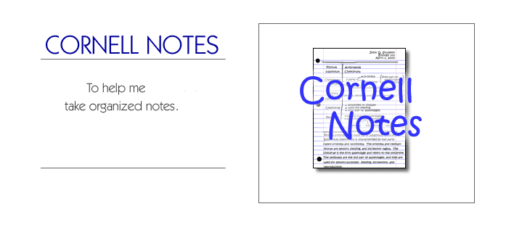
How to make Cornell Notes.

Step 1: Step 2:
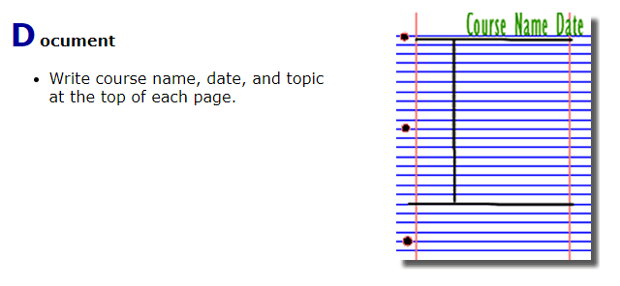
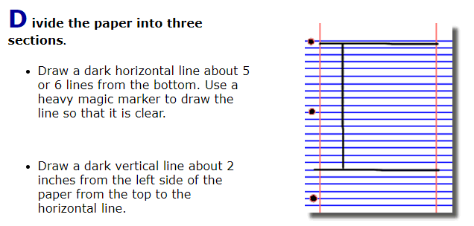

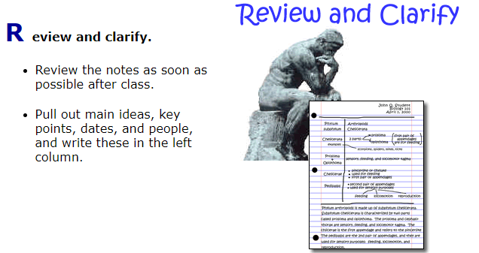
Step 3: Step 4:
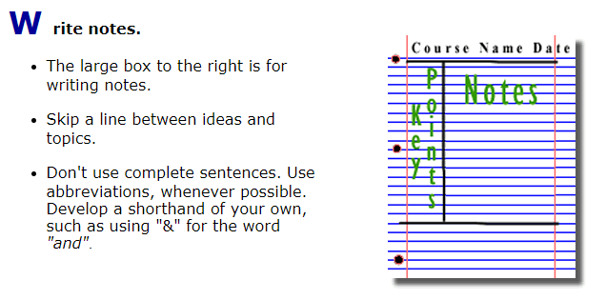
Step 5: Step 6:
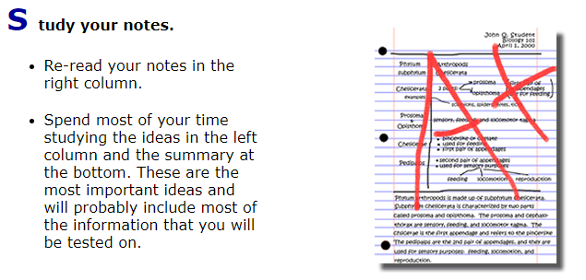
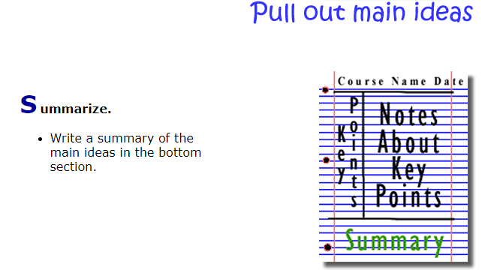

Figure 2: http://coe.jmu.edu/learningtoolbox/images/noteb4.gif

