Transition Pack
A-Level Physics

Research Task
2020
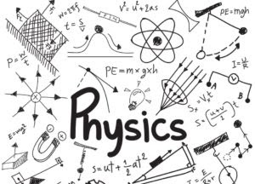
https://www.physics-phenomena.com/2019/08/physicswhat-is-physicsbranches-and-map.html

Physics Research Activity
To get ready for A-level Physics, there are six questions that we would like you to research, two of which you research to a greater level.

Task 1: Make a single page of Cornell notes answering each question.
Click this link for an explanation of this note style and see the next page. Feel free to include diagrams where appropriate.
The six questions are:
- What are protons made up of?
- What is the photoelectric effect?
- Why have we built the Large Hadron Collider?
- Why is Pluto not a planet?
- What are quasars?
- What are the Laws of Motion?
Resources
You can use the following websites as a starting point for these topics.
- https://home.cern/
- https://www.nasa.gov/
- https://www.livescience.com/46558-laws-of-motion.html

Task 2: Research two of the questions to greater detail.
Choose two of the questions above, we suggest the ones you find most interesting, and research them to greater depth. Find out as much as you can about each question.
Impress us with your knowledge!
As a guide, we suggest you at least answer the following questions through your research:
- How did this affect science going forward?
- Who was involved in this and/or built upon this?
- When and where was this discovered?
- Why do you believe this is important?

Submit
- A Word document (or photos if handwritten) for each research question.
- Use diagrams, pictures and equations where appropriate.
- List your sources at the end of the write-up.
- Each write-up needs to be long enough to answer the question and include the points above. We will be disappointed if it is less than 4-5 pages.
- Please make sure everything is clearly labelled with your name.

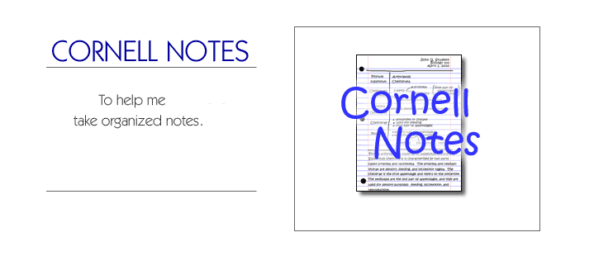
How to make Cornell Notes.

Step 1: Step 2:
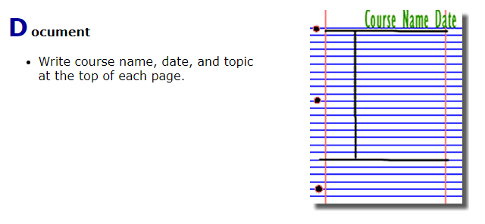
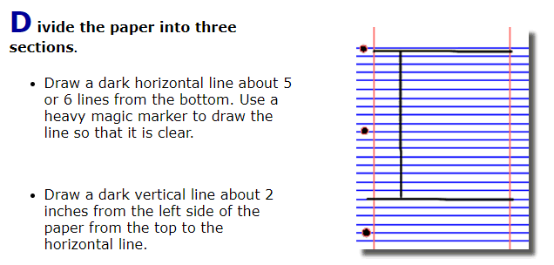

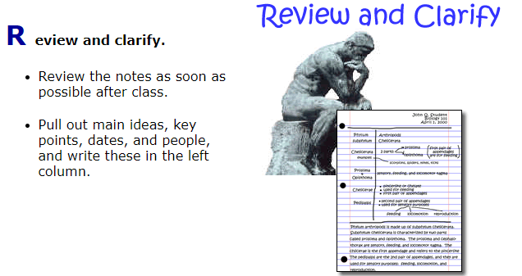
Step 3: Step 4:
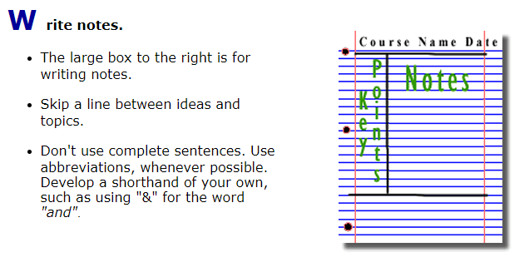
Step 5: Step 6:
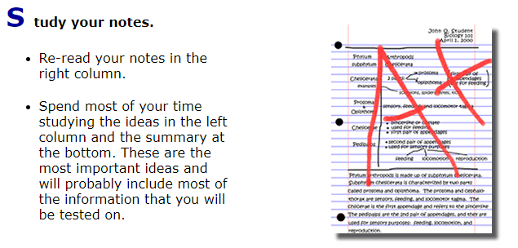
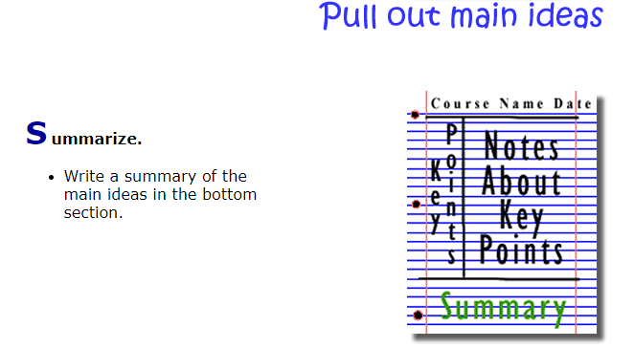

Figure 2: http://coe.jmu.edu/learningtoolbox/images/noteb4.gif

