5th June 2020
Careers Newsletter
7. Coronavirus Special Edition

Hello Blaise High School Students,
I hope you enjoyed your half-term break even though I am sure it was somewhat different to your usual holidays!
Today I want to help you discover the mountain of resources that are available to you, right now, during these strange Coronavirus days.
Just as Charles Darwin theorised with his animals, careers guidance is adapting to change. There has been a rapid response to the effect of school closures and for students not being able to be taught face to face. So, some of our leading careers information websites and local networks and providers have pulled together some excellent resources to support all students to consider their own situation and future plans.
Here is an update:
Careerpilot
https://www.careerpilot.org.uk/

The first thing you will see on their home page in bright yellow, is the heading:

Coronavirus: Keeping your career planning on track
You will see it contains links to Home Learning and Online Tutorials
Each of these links provide further links to activities and lessons for every Year group.
They have also created a page specifically about Coronavirus, with information about jobs and careers that can help in the crisis as well as tips and videos including:
- Careers Actions you can take in lockdown
- How GCSE grades will be decided
- How job growth may have changed as a result of Coronavirus.

Amazing Apprenticeships
https://amazingapprenticeships.com/

As I mentioned in Newsletter 4, which was all about apprenticeships, it is difficult at this time to predict how different job sectors are going to be affected by coronavirus.
Some employers may be more willing to take on apprentices than previously, as they represent to them; value for money and someone they can train to do the job needed. That is why it is best to search for opportunities of interest and seek expert advice.
On the Amazing Apprenticeships homepage click on:
Request Support
https://amazingapprenticeships.com/request-support/

This gives you access to their digital programme.
As well as providing Learn at Home Resources and Interactive Virtual Workshops you can also get virtual one to one support.
They have also recently brought out a Parents & Carers Special Edition pack.
To view this, click on:
Parents, then click on the May Parents’ Pack
https://amazingapprenticeships.com/resource/parents-pack-may-2020/

Local Networks and Providers
Creative Youth Network
https://www.creativeyouthnetwork.org.uk/

Based at The Station in Bristol City Centre but now with many virtual offerings instead.
Scroll down to the bottom of their homepage to find out What’s On – Digital Exhibitions and Events which includes their Online Youth Club.
Also details of all their Online Creative courses

Bristol Works
https://www.bristol.works/

During the mayoral election, one of Marvin Rees’ manifesto pledges was to deliver experience of work and the opportunity of an apprenticeship for every young person who wants one. Bristol WORKS aim is to support this, based on the needs of the young people in the city.
They produce fortnightly newsletters sharing information on careers resources including E-Learning and virtual local events. Have a look at:
https://www.bristol.works/covid-19-newsletter/

West of England Jobs Fair
Bristol City Council are hosting a Virtual Jobs Fair on 24th June from 2-3pm with priority vacancies from employers around the Bristol (Bath/South Glos) area.
During the event employers will be promoting their vacancies on their own Social Media sites and tagging in the event hashtag which is #WestofEnglandJobsFair

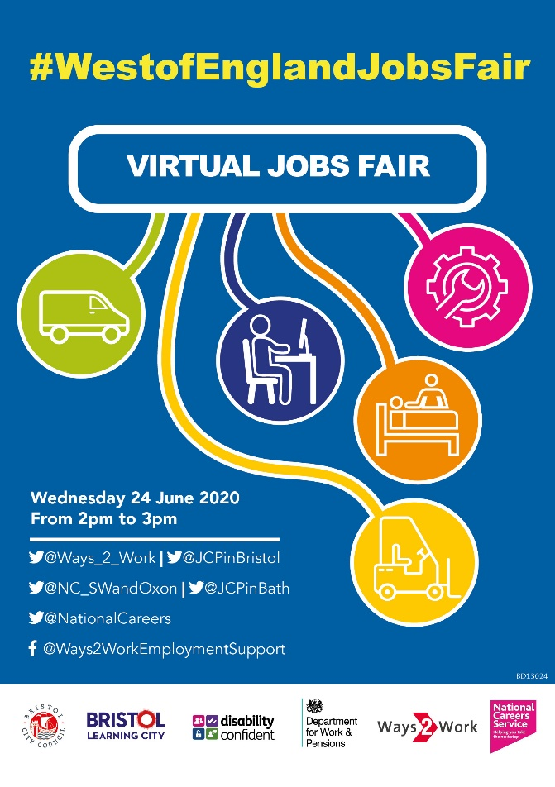

As always, Mrs Brightley and myself are available to discuss anything with you related to careers advice, your Post 16 and future plans, so please contact us and we will be happy to help.

Steve Newman
Independent Careers Adviser & Progression Coach
snewman@blaisehighschool.co.uk

Mrs Brightley
cbrightley@blaisehighschool.co.uk

