Tudor Projects: Complete at least two of the below!
- Create a timeline of the War of the Roses. On it, identify the start of the war, and five key battles including details of what, when where and consequences.
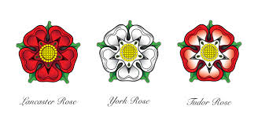
- Research what life was like in Medieval England. Create a fact file covering each of the following topics – landscape, economy, education and food.
- Research the Princes in the Tower. What do you think happened to them? Did Richard III kill them? What were his motives? How would this affect how people in England perceived Richard?
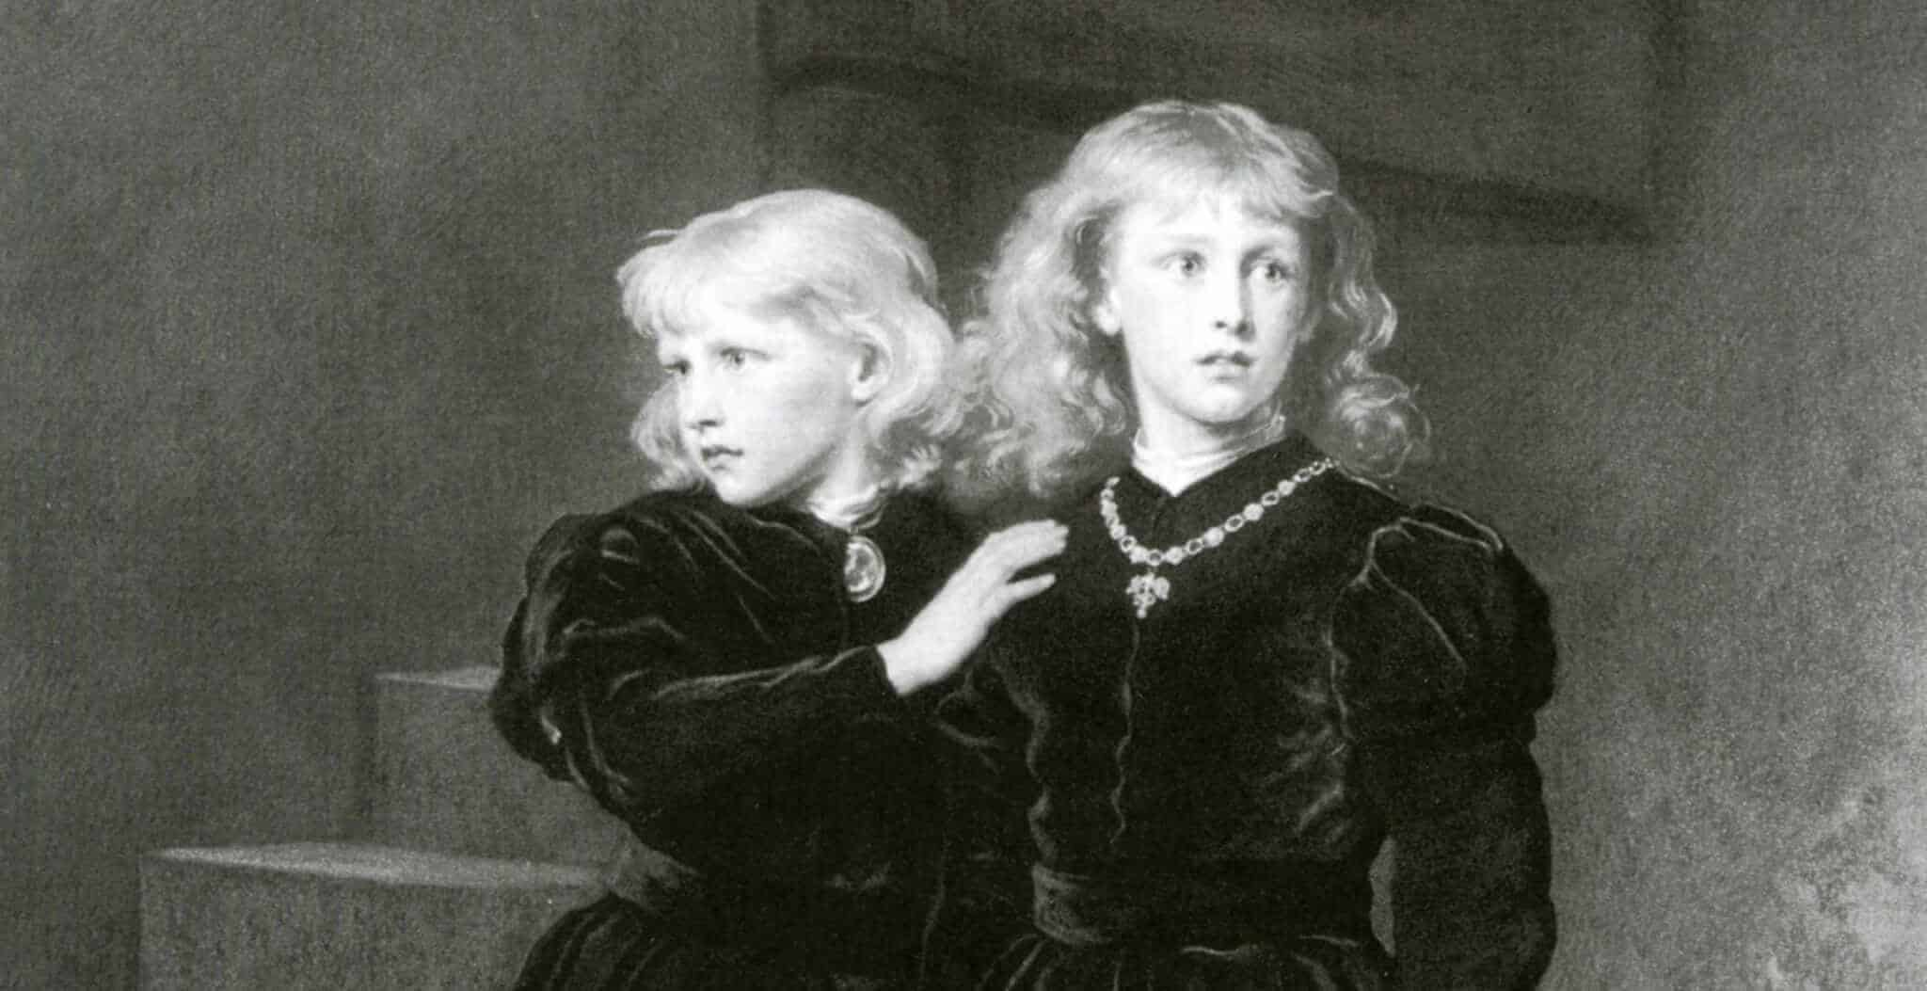
- What role did religion play in Tudor England? What was the religious landscape of Europe in the C16th? Tip: Download and annotate a map of Europe.

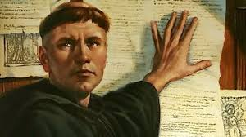

Tudors Resource List: Your main source of information will be from the websites listed below. The TV series ‘The Hollow Crown’ and ‘Wolf Hall’ can be seen on the streaming site BritBox (free trial for 30 days, just remember to cancel before you get charged!) You can rent the other films/series on Amazon if you are feeling keen!
Film Resources | - The White Queen  - Richard III (1995)  - The Other Boleyn Girl (2003)  - The Hollow Crown  - Wolf Hall (2015)
Useful Websites | - http://www.historylearningsite.co.uk/medieval-england/  - http://www.warsoftheroses.com/  - http://www.britannica.com/event/Wars-of-the-Roses  - http://www.richardiii.net/9_1_wotr.php  - http://www.historyextra.com/article/military-history/12-facts-wars-roses  - http://shakespeare.mit.edu/richardiii/full.html  - http://www.sparknotes.com/shakespeare/richardiii/  - https://www.youtube.com/watch?v=ZH7CKzhCyyA  - http://tudorhistory.org/monarchs/  - http://www.royal.gov.uk/HistoryoftheMonarchy/KingsandQueensofEngland/TheTudors/TheTudors.aspx  - http://www.historyonthenet.com/tudors/monarchs.htm  - http://tudorhistory.org/  - http://tudortimes.co.uk/

Germany Projects: Complete at least two of the below!
- Search for 4 Nazi propaganda posters. Annotate them in as much detail as you can and explain how they would have won support for the Nazi party. http://www.bc.edu/bc_org/avp/cas/his/CoreArt/prop/propmain.html
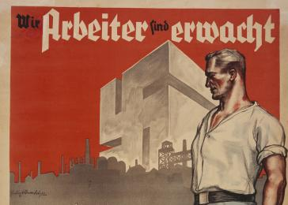
- Construct a biography for the following key individuals including dates, early life, key achievements, failures or problems:
a. Gustav Stresemann
b. Friedrich Ebert
c. Wolfgang Kapp
d. Adolf Hitler
e. Heinrich Bruning
f. Franz von Papen
3) Study Germany during the First World War and write an account of their involvement. Be sure to answer the questions: What role did they play on the war? What key battles were they involved in? What impact did the war have on Germany as a country?

- Create a fact file on each of Germany’s Kaisers between 1871–1918. You must include details of their rule and the impact · Wilhelm I (1871–1888) · Friedrich III (9 March-15 June 1888), who ruled for 99 days · Wilhelm II (1888–1918)
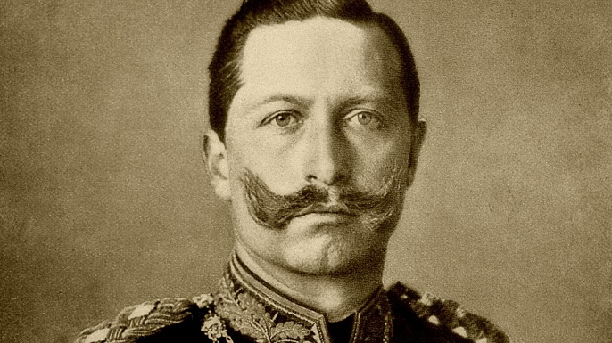
Germany Resource List: Please see below for some useful websites to help you with your research. There are also some films/dramas that you can watch for a bit of flavour on the period, but bear in mind these are often exaggerated for dramatic effect. You can rent/buy from Amazon, but one is on Netflix and another for free on YouTube.
Film Resources | - The Wonderful and Horrible Life of Leni Riefenstahl. (1993) – A documentary of the film director’s life.  - Hitler, the Rise of Evil (2003) – Dramatized story of Hitler’s career – on YouTube (Here)  - Triumph of the Will (1935) – Propaganda film on Hitler – on Amazon Prime  - The Lives of Others (2006) – Life in East Germany during the Cold War.  - The Pianist (2002) – Life of Jewish musician during Nazi reign – on Netflix  - Schindler’s list (1996) – showing how people attempted to escape the Holocaust  - Anne Frank The Whole Story (2006) – two part mini-series based on the Diary of Anne Frank.
Useful Websites | - https://www.britannica.com/place/Germany/The-Third-Reich-1933-45  - https://www.historyonthenet.com/world-war-1-comprehensive-overview-great-war  - https://www.johndclare.net/Weimar1.htm  - https://www.historyextra.com/period/first-world-war/operation-alberich-ww1-germany-retreat-what-happened/  - https://www.historyextra.com/period/first-world-war/ww1-david-olusoga-african-asian-beyond-the-western-front/

Civil Rights Projects: Complete at least two of the below!
- Research the causes of the American Civil War. Was it caused by slavery? Look at why some states were pro-slavery, and others were against slavery.
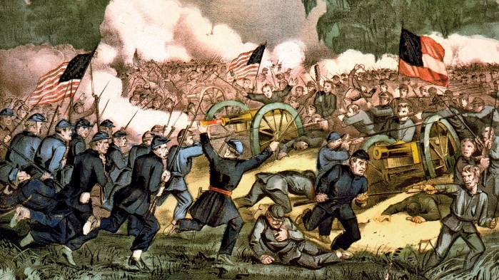
- Create a timeline from 1865-1900. How did life change for Black Americans from the end of the American Civil War, to the start of the 20th Century? Make sure to include details such as the Ku Klux Klan, the Jim Crow Laws and migration.
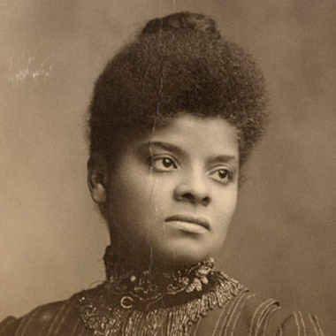
- Create profiles for high profile Black Civil Rights activists. Include details on their personal lives, the actions they took, and what happened to them. Key people/groups to include are:
Booker T. Washington
Ida B. Wells
Niagara Movement
W.E.B Du Bois
Film Resources | - Ken Burns: The Civil War – on YouTube (here) Just the first episode, though watch if you want!
Useful Websites | - http://www.loc.gov/teachers/classroommaterials/primarysourcesets/  - http://www.modjourn.org/render.php?view=mjp_object&id=crisiscollection  - http://voicesofdemocracy.umd.edu/wp-content/uploads/2010/07/logan-wells.pdf  - https://pdfs.semanticscholar.org/c623/a75e231765d992347fbdbdb2f1e523059343.pdf  - https://www.tuskegee.edu/discover-tu/tu-presidents/booker-t-washington  - https://www.britannica.com/

